

KAZAKH-BRITISH TECHNICAL UNIVERSITY
SCHOOL OF INFORMATION AND TECHNOLOGY

Automation Of Standard Technological Processes and Manufacturing

DEVELOPMENT OF AN AUTOMATED CLIMATE CONTROL SYSTEM FOR A GRAIN STORAGE FACILITY BASED ON THE SMART CITY CONCEPT

Prepared by: Collins Masimba
Checked by: Samigulina Z I
Prof SITE
Ph.D

Almaty, 2025
CONTENT
Introduction 2
1.0 Technological Part. 3
1.1 Description of the Technological process for the automation of Grain Storage Facility Detection. 4
1.1.1 Problem Statement. 6
1.2 Block Diagram Process 7
1.3 Description of the Parameters. 10
Conclusion. 13
REFERENCE 14

Introduction
Grain storage plays a critical role in the economies of the developed and developing countries. Therefore its essential to provide a proper monitoring of the grain storage facility to reduce the grain loss. The current grain storage facility involves a lot of human efforts in all the activities and this reduces efficiency and increases the time consumption [1]. In our proposed projects we are trying to analyze such challenges. In this project we proposed a fully automated grain storage system using PLC and SCADA. The main objective of the research is control and maintain parameters such as temperature and humidity using automated system that is based on a smart city. Implementing this prevents the formation of micro-organisms that will spoil the grains. The main parameter that is essential for proper storage of grains is temperature which is taken as the input parameter to be controlled using PLC. The Scada system acquires the required data and monitors the overall process.
In this project we will develop an automated system for heating, ventilation and air conditioning process for the grain storage facility. In this project a heat exchanger was selected as the control object. A mathematical model of the control object was formulated and it was important for stability, controllability and observability. The PID regulator was implemented and its coefficients were developed.
Our technological process will involve the provision of a remote detection of oil leakage from the main pipelines. Using the SCADA system we are going to monitor the changes in all the pumping technological parameters in real time as described. The mathematical formulation of the problem for controlling the operating modes of the technological objects and the main storage facility was also obtained. The research proposes the use of temperature sensors and provides methods of detecting humid and low temperatures in the grain storage facilities. Using PLC we are going to analyse the data received from the temperature and detect if there are any variations. In case of any variations then it means that there are high humid which might affect the grains. Recent studies have proposed methods that use artificial intelligence and machine learning to control humidity and temperature in the grain storage facilities. The AI uses an analytical approach that depicts he absorption of the chiller performance while accounting for the solar intermittency. The Computational Fluid Dynamics have also been deployed to investigate the natural ventilation of large air masses.
Su Zhiyuan et al developed an intelligent control system for the grain dryers and the touch screen technology. They also implemented the fuzzy PiD Algorithm reasoning rules to control the moisture content of the grain after leaving the machine in the process of drying with a large lag. Zhang Liyuan et al designed a grain dryers control system. The grain dryers control was done using the Mitsubishi FX5U series PLC. At the end he achieved an automatic and manual full process of grain drying process. This also focused on the analysis of temperature and humidity control module and drying module.
The development and application of these technologies, it can be seen that the control system for the grain dryers and moving towards a more intelligent and efficient direction. This is with great significance for ensuring food security and improving the production efficiency.

1.0 Technological Part.
Among all the technologies, the real time monitoring of grain temperature and moisture inside the silos was considered as one of the most critical factors for effective storage. It played a pivotal role in early warning for food safety, preservation of grain quality and guiding aeration and energy-saving strategies and solutions. The temperature and moisture of the stored grain exhibited pronounced spatial variability. In this research work we will implement the distributed temperature monitoring. This will be done using the cable-based systems which is equipped with the thermistors, thermocouples and digital temperature sensors.
The grain dryer control system in the Silo is evolving towards multifunctioning integration and modular design. The system will be able to automatically adjust according to the drying requirements of different types of grain. This ensures that the machine can achieve multiple functions. On the other hand, the modular design makes the system upgrades and maintenance more convenient. This allows the user to replace or upgrade specific modules based on their needs. This enhances the system's flexibility and adaptability.

1.1 Description of the Technological process for the automation climate system Monitoring System in a Grain Storage Facility.
In the proposed system, the temperature and humidity are maintained at an optimum temperature and humidity based on the grain type. The main component is the heat exchanger which will be used to control the temperature and dehumidification of the grain storage facility. Air conditioners work by extracting heat from indoor air and expelling it outdoors. This process generates cool air that is then circulated throughout the space, effectively lowering the temperature. The heat exchanger is the core component responsible for this heat transfer, and its efficiency directly determines the unit's overall cooling performance.

A heat exchanger is a device that facilitates heat transfer between two fluids without allowing them to mix. Its performance depends on several factors, including temperature differential, heat transfer surface area, fluid flow rates, and flow configurations. Heat exchangers are essential across diverse industries, such as petroleum refining, food processing, petrochemicals, power generation, nuclear energy, and aerospace applications. Among various types, shell-and-tube heat exchangers are the most widely used due to their ability to handle a broad range of temperatures and pressures. This is the heat exchanger that we are going to use in our research project. Compared to double-pipe designs, they provide a higher surface-to-volume ratio and can be easily manufactured in various sizes and configurations. These exchangers are robust under high pressure, and their modular design allows straightforward disassembly for maintenance and cleaning.

A shell-and-tube heat exchanger evolves from the basic double-pipe concept. Instead of a single tube inside a larger pipe, it consists of multiple tubes bundled within a cylindrical shell. One fluid flows inside the tubes, while the other circulates around them in the space between the tubes and the shell. In grain storage facilities, HVAC systems play a critical role in maintaining food safety, quality, and operational efficiency. They precisely control temperature and humidity to create optimal conditions for storage, processing, and preservation—preventing spoilage, extending shelf life, and ensuring compliance with regulatory standards—while also promoting energy efficiency and sustainability.

The RF module acts as a transmitter to transmit data from the sensors to the controller which in our case is the Schneider PLC. The temperature sensor module is connected to the PLC end and then it acts as a receiver and a data is then fed to the PLC. In the PLC, an acceptable range of temperature data is set. The humidity sensors module is also connected to the PLC to monitor the humidity levels. The system runs on real-time. Whenever there is a change in humidity levels and temperate it means there is a high humidity and unacceptable temperature which needs to be regulated to optimum levels. The PLC will detect the difference in temperature and humidity levels across the acceptable range. This will generate an alarm in the PLC-HMI. In case the temperature and humidity levels is high then the alarm will be set as a high priority on the other hand of the leakage is low then the alarm will be set as a low priority.
The simulation was performed on MatLab Simulink to ensure that the performance of the controller meets the requirements. The controller was done using ZN (Zieglar and Nicholas ) PID. In the research we developed a new technique based on the autoregressive and data analysis of the humidity and temperature data to determine the leakage and decision to be made instantly to control the leakage in the pipes. The numerical results demonstrated that the proposed technique was able to detect the leakage in the presence of uncertainty. The detects and the estimates leaks were very accurately. We modeled the pipeline model equations using the ARX-Laguerre technique. Therefore, the proposed algorithm will be based on the ARX-Laguerre fuzzy PID Algorithm to detect and locate the leaks in the pipeline. For analysis we will compare this method with the rest of the methods.

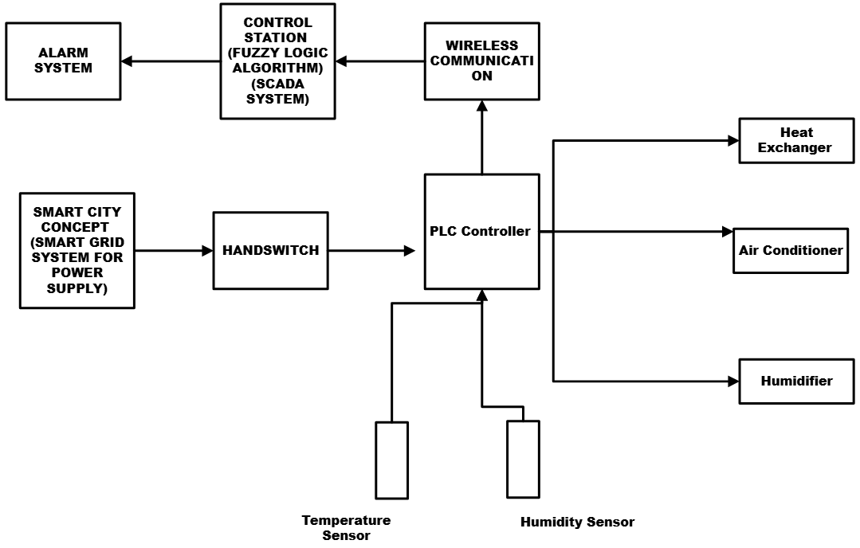

Figure 1 Process flow Visualization Diagram

The figure shows an automated climate control system for a grain storage facility, developed under the smart city concept, establishes a robust, intelligent framework to maintain optimal environmental conditions and safeguard post-harvest grain quality in urban and peri-urban settings. At its foundation lies a smart grid power supply system that ensures uninterrupted, demand-responsive electricity by integrating with municipal energy networks. This enables dynamic load management and incorporation of renewable micro-sources to achieve near-100% operational reliability while aligning with city-wide sustainability goals.
Central to the architecture is a Programmable Logic Controller (PLC). This serves as the primary processing unit, that receives a real-time data from distributed sensors monitoring temperature, relative humidity, and grain moisture content. This data is transmitted wirelessly using Modbus Protocol cause we are using Schneiderlin PLC system, which not only connects field devices to the PLC but also interfaces with the broader municipal IoT infrastructure, facilitating city-level aggregation of food storage resilience metrics.
Supervisory control is done using the SCADA platform equipped with a fuzzy logic algorithm, specifically engineered to handle the nonlinear and coupled dynamics of silo micro-climates. Unlike conventional PID controllers, the fuzzy PiD inference system emulates agronomic expertise by processing linguistic rules such as “if temperature is moderately high and humidity is critically elevated, then increase ventilation intensity.” This generates precise actuator set-points, thereby minimizing energy waste and preventing conditions conducive to mold or pest proliferation.
Three climate parameters operate in parallel under PLC command this include; an air conditioning unit for cooling and dehumidification, a heat exchanger for condensation-safe reheating using recovered urban waste heat, and an ultrasonic humidifier for moisture restoration during low-humidity periods, with water potentially sourced from municipal grey-water loops. A physical hand switch panel provides mandatory manual override capability, ensuring operational continuity during sensor failure or scheduled fumigation, in compliance with food safety and fail-operational standards. The hand switch also acts as a safety Alarm button.
An independent alarm subsystem continuously monitors all parameters against safe grain storage thresholds temperature between 15–20 °C, and relative humidity at 60–65 %, triggering multi-channel alerts (visual, auditory, and GSM-based) that escalate to both facility managers and, when critical, the city’s emergency response dashboard. This integration transforms individual silos into active nodes within a smart city food security network, enabling predictive analytics, resource optimization, and rapid intervention across urban grain storage clusters.
The resulting system delivers autonomous climate regulation with grain loss rates below 1 % over 12–24 months, achieves 20–30 % energy savings compared to traditional HVAC approaches, and exemplifies scalable, data-driven infrastructure that strengthens urban food system resilience through seamless alignment with smart city connectivity, sustainability, and governance frameworks.

1.1.1 Problem Statement.

Loses during the grain storage is unacceptable cause it can lead to lack for food for any country. This is owed to growing needs of the world’s population and climate challenges. Monitoring systems in combination with measured data analytics can help in preventing the insects and mold damage. The mold damage has become a serious concern cause this always leads to massive food poisoning which can be fatal. This is in comparison to insects and rodents destroying the stored grains. Based on the recent research food wastage is attributed to consumers and ins the supply chain is responsible for 6% of the global greenhouse gas emissions. According to the Food and Agricultural Organization of the United Nations FAO. The number of undernourished people in the world has increased in 2020. This was even before the Covid 19 pandemic. That is why food loss is closely monitored by the world leaders and researchers. The presence of the live insects can also lead to serious consequences for the rejection of all the grain lot. This will result to a significant economic loss to the grain supplier. Several technologies have been developed to monitor prevent grain loss in the storage facilities. Modified atmospheric conditions not only prevent mold but its also unconducive for the existence of the insects in the storage facilities.
In the research we are going to implement the Volume based method and a temperature point analysis approach to detect the leaks. This was implemented using the PLC, SCADA and MatLab Software. The Fuzzy Logic Algorithm was deployed to check on the performance and tests. The PLC software is very essential in operating the temperature sensors and humid sensors. In the research we developed a new technique based on the autoregressive and data analysis of the humidity and temperature data to determine the optimum conditions of operation and decision to be made instantly to control the optimum temperature conditions. The numerical results demonstrated that the proposed technique was able to detect the unfavorable conditions in the presence of uncertainty. The detects and the estimates conditions were very accurately.

1.2 Block Diagram Process
To clearly understand the logic of interactions between the smart city concept and climate control system concept of the grain storage facility, we are going to present the technological sequence in form of a blocked diagram.

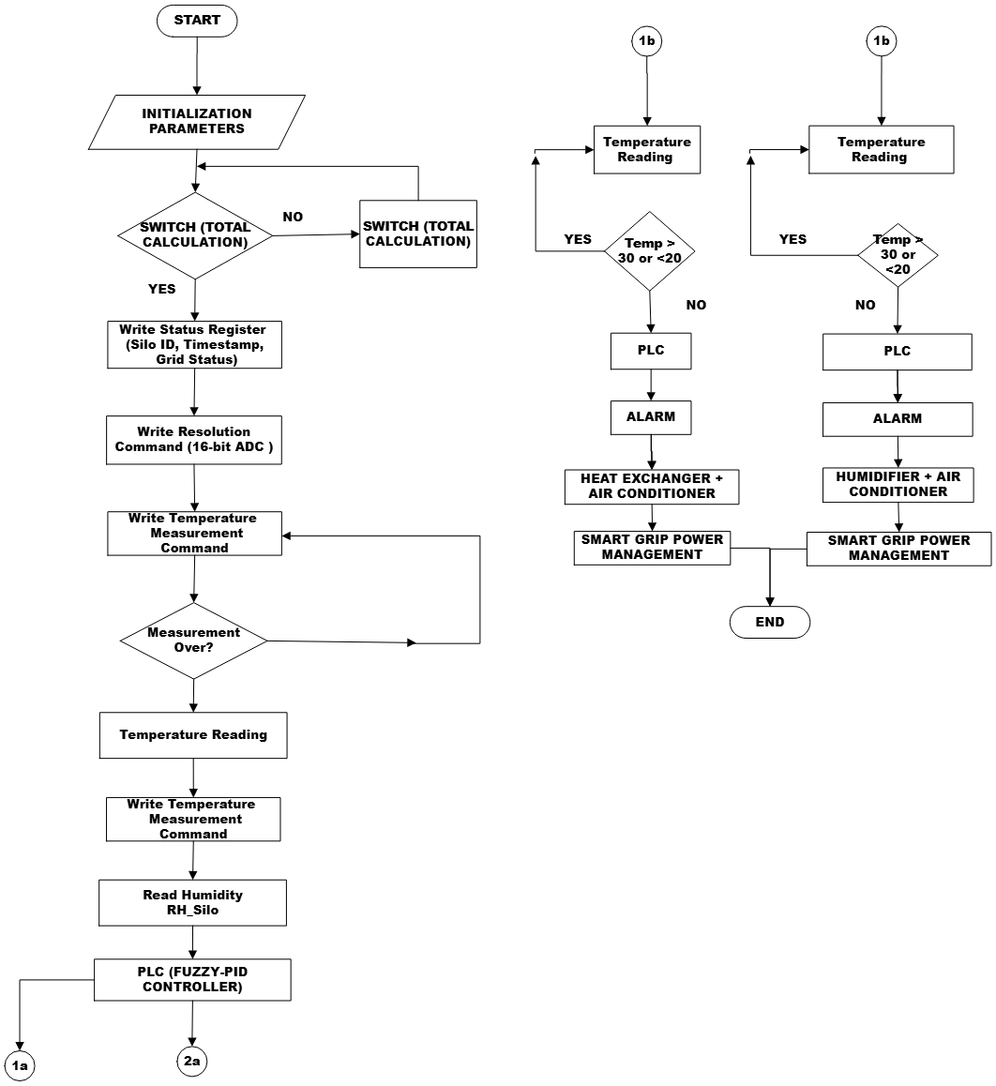

Figure 2 The Process Flow Diagram

The flow diagram in figure 2 shows a dual-path automated climate control system tailored for grain storage facilities, seamlessly integrating hybrid fuzzy-PID control with smart city infrastructure to ensure precise micro-climate regulation and long-term grain viability. The process begins with a START trigger, followed by Initialization Parameters, where critical set-points are established temperature between 15–20 °C, and relative humidity at 60–65 %, sampling intervals (60 seconds), and control cycle duration (300 seconds) from PLC. The system then enters a conditional Switch (Total Calculation) block, which determines whether a full circulation cycle is required. If affirmative, the counter resets (switch(total_circulation) = 0), enabling comprehensive sensor polling and actuator recalibration; otherwise, it proceeds incrementally.
In main loop the primary control sequence unfolds sequentially: the system writes operational metadata. This includes silo ID, timestamp, and real-time smart grid status into a status register to support traceability and city-level analytics. A Write Resolution Command will configure the analog-to-digital converter for high-fidelity signal acquisition. The Write Temperature Measurement Command initiates sensing, followed by a robust Measurement Over? decision gate implemented at this stage. If the measurement is incomplete, the command retries automatically, ensuring fault tolerance. Upon successful acquisition, Temperature Reading (T_silo) is captured, followed by Read Humidity (RH_silo), delivering multi-variable environmental data to the PLC (Fuzzy-PID Controller). This hybrid controller is the system’s intelligent core: the fuzzy logic layer processes nonlinear interactions such as temperature-humidity coupling, ambient forecast influence) using linguistic rules to dynamically adjust set-points and select operational modes, while the PID inner loops tuned with gains such as Kp=2.1, Ki=0.08, Kd=1.5 for temperature—execute precise, low-overshoot tracking of air conditioner duty cycle, humidifier mist rate, and heat exchanger valve position.

The continuous loops operates as a real-time safeguarding branch. Two parallel Temperature Reading inputs feed into conditional diamonds: one checks if Temp > 30 or < 20, and the other evaluates Temp > 30 or < 20 (redundant for enhanced reliability). Upon breach detection, the system activates the PLC, which triggers an ALARM (strobe, siren, GSM alert) and engages corrective actuation under Smart Grid Power Management. In the first branch, Heat Exchanger + Air Conditioner activates to gently reheat or cool the silo core, preventing condensation shock or overheating; in the second, Humidifier + Air Conditioner restores moisture and thermal balance during dry or extreme conditions. Both paths leverage Smart Grid Power Management to schedule high-load operations during off-peak tariffs, integrate urban waste heat, and enable demand-response participation reducing energy costs by 25–35 % and aligning with municipal sustainability targets.
The PLC serves as the convergence point, synthesizing fuzzy-supervised PID outputs to modulate actuators via PWM or analog signals. The ALARM system continuously monitors all thresholds, escalating critical deviations to facility managers and the city’s food security dashboard via LoRa/5G wireless telemetry. The END state is reached upon cycle completion, but the Switch (Total Calculation) ensures continuous looping with incremental subcirculation counting (general_circulation = subcirculation + 1), enabling adaptive duty cycles based on grain load, season, or ambient extremes such as Almaty’s –20 °C winters to +35 °C summers.

1.3 Description of the Parameters.
Mathematical modelling is very essential in the implementation of the control process. For the mathematical model to be developed we need control parameters. The main control parameter is temperature and humidity. We also have other parameters such as the speed of air and air flowrate from the heat exchanger.

Table 1 Parameter Table

No | Parameter Name | Value | Unit | Technical Recommendation | Description | I/O
1 | Temperature | 15-18 | $$℃$$ | $$±0.5$$ | Air temperature inside the grain storage silo; prevents mold growth and respiration heat | Input
2 | Relative Humidity | 60-65 | % | $$±2 \%$$ | Moisture level in the air; high RH leads to condensation and grain spoilage | Input
3 | Coolant Flow Rate | 0.5-3.0 | $$m^{3}/h$$ | Adjust dynamically via 4-20 mA Proportional valve based on cooling load | Flow of Chilled water through the tube side of the heat exchanger; adjusts cooling capacity. | Output
4 | Air Flow Rate | 2590 | $$m^{3}/h$$ | Use VSD to modulate the speed of the fan | Volume of the conditioned air circulated through the grain mass via fans | Output

Conclusion.
The proposed multisensory temperature and humidity monitoring has successfully fulfilled its requirements of real-time supervision of the grain storage conditions using PLC. This approach offers a practical solution for the largescale temperate and monitoring the grain storage conditions. The aim was to utilize the principles of instrumentation so that the standard of storage can be improved.

REFERENCES

Wrigley, C.; Batey, I.; Miskelly, D. Chapter 1—Assessing and Managing Quality at all Stages of the Grain Chain. In Cereal Grains, 2nd ed.; Woodhead Publishing: London, UK, 2017; pp. 3–25.

Ziegler, V.; Paraginski, R.T.; Ferreira, C.D. Grain storage systems and effects of moisture, temperature and time on grain quality—A review. J. Stored Prod. Res. 2021, 91, 101770.

Rizwan, M.; Atta, B.; Ali, M.Y.; Ashraf, I.; Arshad, M.; Tahir, M.; Rizwan, M.; Sabir, A.M.; Shehzadi, N.; Khalid, U.B.; et al. The comparison of interstitial relative humidity and temperatures of hermetic and polypropylene bag for wheat grain storage under different agro-climatic conditions of rice-wheat ecosystem of Pakistan: Effect on seed quality and protection against insect pests. J. Stored Prod. Res. 2022, 96, 101936.

Jianyao, Y.; Zhang, Q.; Ge, L.; Chen, J. Technical methods of national security supervision: Grain storage security as an example. J. Saf. Sci. Resil. 2023, 4, 61–74.

Wu, W.; Cui, H.; Han, F.; Liu, Z.; Wu, X.; Wu, Z.; Zhang, Q. Digital monitoring of grain conditions in large-scale bulk storage facilities based on spatiotemporal distributions of grain temperature. Biosyst. Eng. 2021, 210, 247–260.

